1.

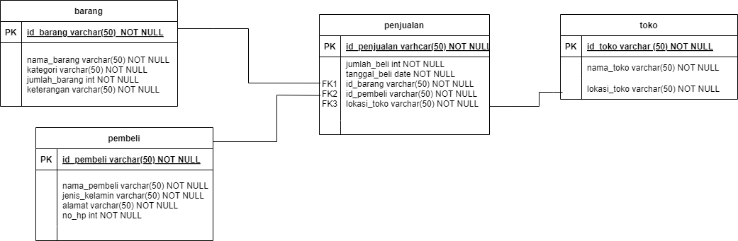

2.

**Partisi data**

CREATE PARTITION FUNCTION PF_tanggalbeli (DATE)

AS RANGE LEFT FOR VALUES ('2022-01-01'2023-01-01', '2024-01-01');

CREATE PARTITION SCHEME PS_tanggalbeli

AS PARTITION PF_tanggalbeli

TO ([PRIMARY], [Sales2022], [Sales2023], [Sales2024]);

**Indexing**

CREATE INDEX idx_penjualan ON transaksi (lokasi_toko);

CREATE INDEX idx_penjualan ON transaksi (tanggal_beli);